Part 1
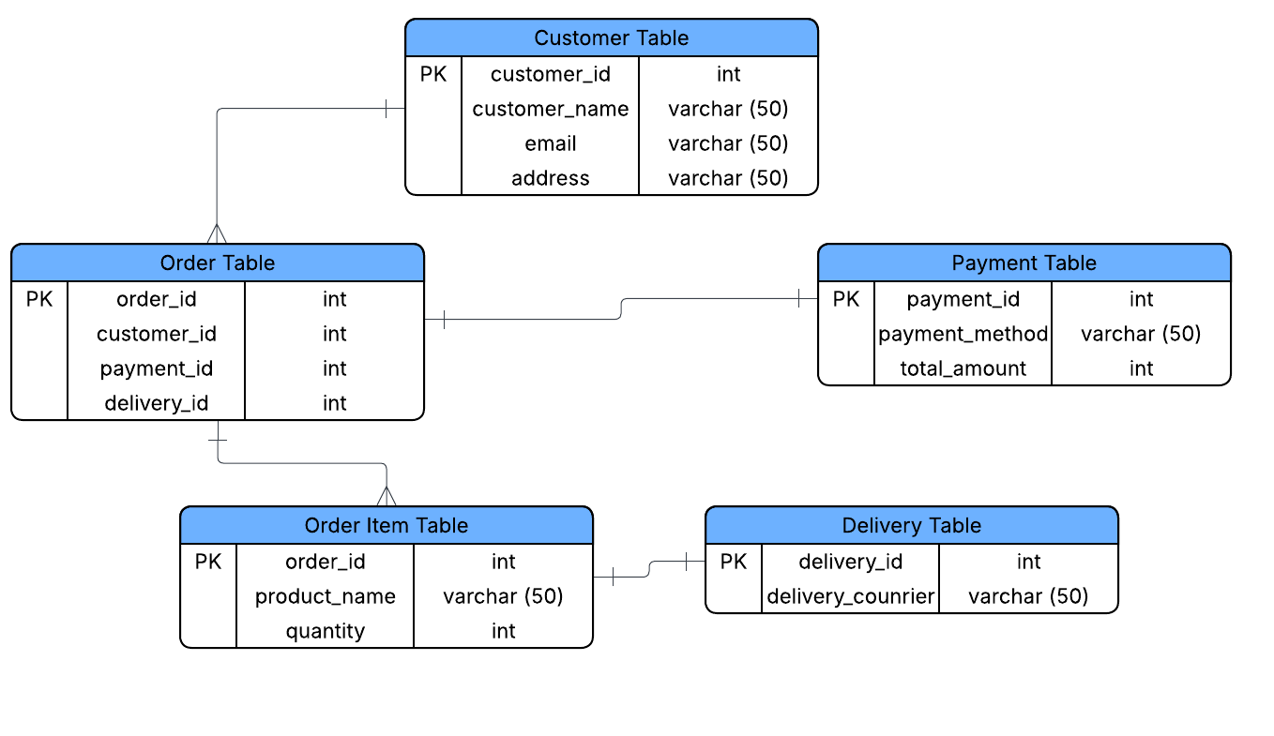

Part 2

1NF

order_id | customer_name | Email | Address | product_list | quantities | total_amount | payment_method | delivery_courier
101 | Ana Cruz | cruzaa@gmail.com | Lipa City | Laptop, Mouse | 1,2 | 52000 | Gcash | J&T Express
101 | Ana Cruz | cruzaa@gmail.com | Lipa City | Laptop, Mouse | 1,2 | 52000 | Gcash | Lazada
101 | Ana Cruz | cruzaa@gmail.com | Lipa City | Laptop, Mouse | 1,2 | 52000 | Gcash | Shopee
102 | Juan Dela | juanjd@gmail.com | Batangas City | Phone, Headphone, Charger | 1,1,1 | 25000 | Credit Card | Ninja Van Express
102 | Juan Dela | juanjd@gmail.com | Batangas City | Phone, Headphone, Charger | 1,1,1 | 25000 | Credit Card | Ninja Van Express

2NF
Customer table
order_id | customer_name | Email | Address
101 | Ana Cruz | cruzaa@gmail.com | Lipa City
102 | Juan Dela | juanjd@gmail.com | Batangas City

Product table
Product_list | Quantities | Total_amount
Laptop, Mouse | 1,2 | 52,000
Phone, Headphone, Charger | 1,1,1 | 25,000

Payment table
Payment_method | Delivery_courier
Gcash | J&T Express
Credit Card | Ninja Van Express

3NF
order_id | customer_name | Email | Address | product_list | quantities | total_amount | payment_method | delivery_courier
101 | Ana Cruz | cruzaa@gmail.com | Lipa City | Laptop, Mouse | 1,2 | 52000 | Gcash | J&T Express
102 | Juan Dela | juanjd@gmail.com | Batangas City | Phone, Headphone, Charger | 1,1,1 | 25000 | Credit Card | Ninja Van Express

Final Schema

Reflection Questions:
1. Why is it important to normalize data?
2. What problems could happen in the online retail store if the database stays
unnormalized?
3. How can ERDs help developers and business owners understand the system
better?

Answers:
- reduces data redundancy, enhances data consistency, and improves data integrity, leading to more accurate, efficient, and reliable data management and analysis.
- An unnormalized database in an online retail store can lead to data redundancy, causing inconsistent data, insertion, update, and deletion anomalies.
- ERDs help both developers and business owners understand a system by providing a clear, visual blueprint of the database structure, defining entities, their attributes, and how they relate to one another.

